SQL Assignment 1

1. Create database :

Input : create database Northwind

Output :

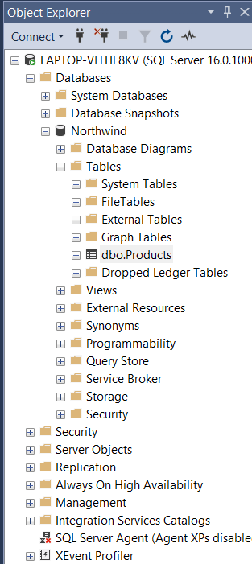

2.create Table

Input:

INSERT INTO Products

values(1, 'apple', 1,1,200,18,39,0,10,1),

(2, 'banana', 1,1,180,19,17,34,15,1),

(3, 'orangr', 1,1,170,10,13,56,0,0),

(4, 'mango', 2,3,150,22,53,10,0,1),

(5, 'grapes', 2,3,210,21,23,0,50,0),

(6, 'pineapple',3,3,140,25,45,0,0,1),

(7, 'pomegranate',3,2,220,30,15,13,0,0),

(8, 'avocado', 3,2,170,40,6,0,13,1),

(9, 'coconut', 3,4,190,97,29,67,34,0),

(10, 'papaya', 4,4,140,31,31,0,62,0),

(11, 'watermelon', 4,6,120,21,22,89,14,0),

(12, 'dragonfruit', 5,6,220,38,86,34,0,1),

(13, 'strawberry', 5,7,130,6,24,11,0,1),

(14, 'blueberry', 5,8,110,23,35,12,0,1),

(15, 'blackberry', 6,9,190,15,40,12,20,0),

(16, 'cherry', 6,4,150,18,34,0,25,0),

(17, 'pear', 6,6,230,13,67,0,0,1),

(18, 'cusardapple',6,8,11,120,22,0,0,0),

(19, 'guava', 7,3,120,22,89,56,0,1),

(20, 'raspberry', 7,9,30,120,45,41,40,0);

3. Output:

input : select \* from Product

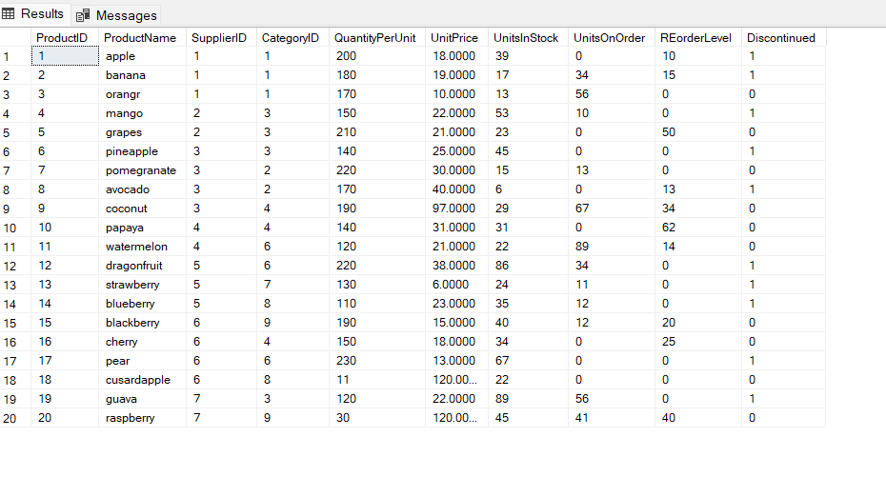

Query 1 :

Write a query to get a Product list (id, name, unit price) where current products costless than $20.

Output :

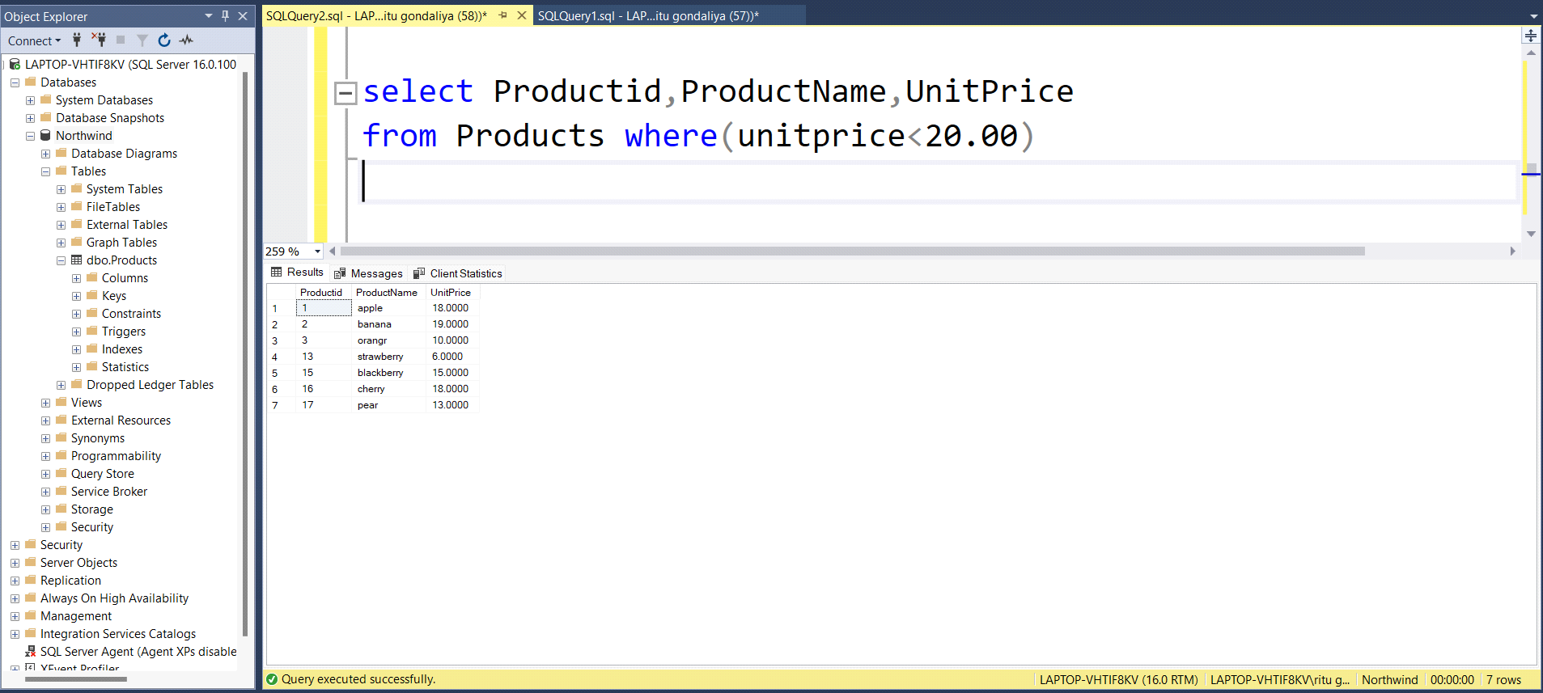

Query 2 :

Write a query to get Product list (id, name, unit price) where products cost betwee $15 and $25

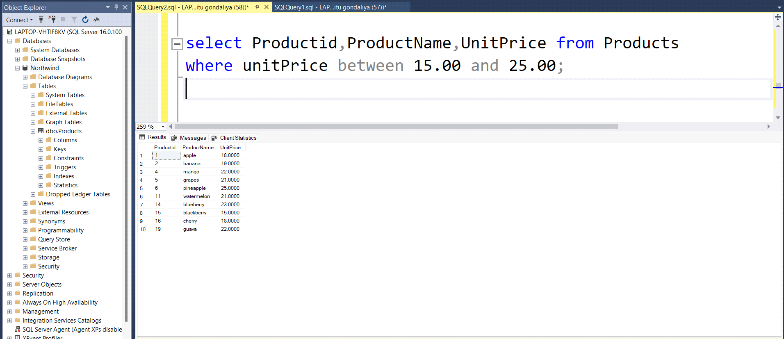

Query 3 :

Write a query to get Product list (name, unitprice) of above average price

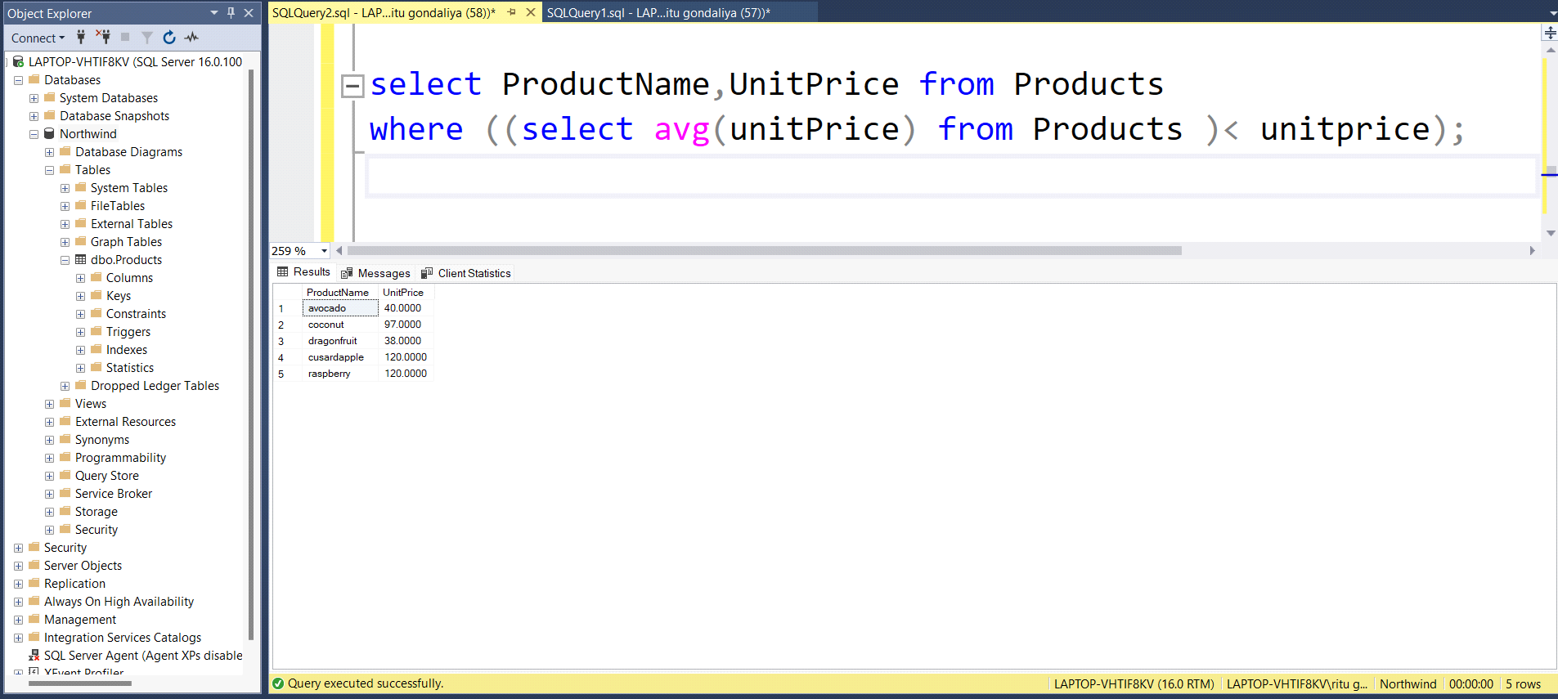

Query 4 :

Write a query to get Product list (name, unit price) of ten most expensive products

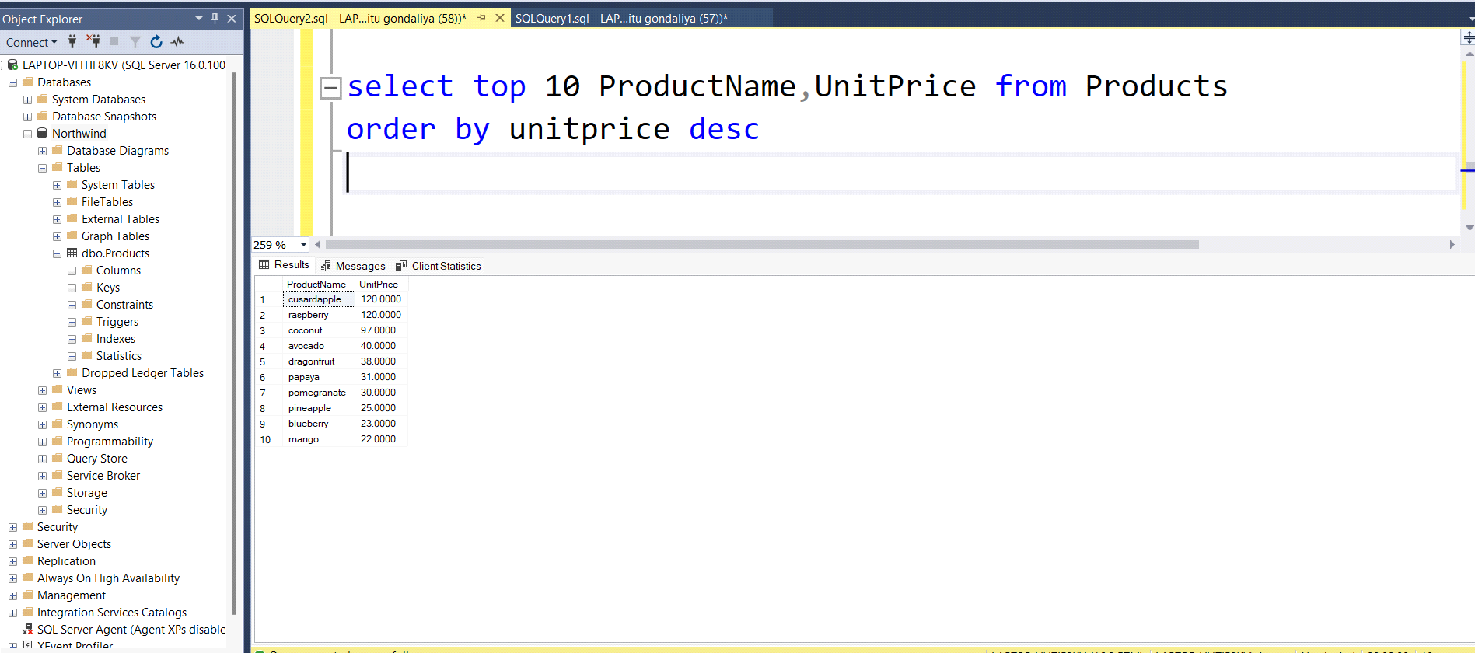

Query 5 :

Write a query to count current and discontinued products

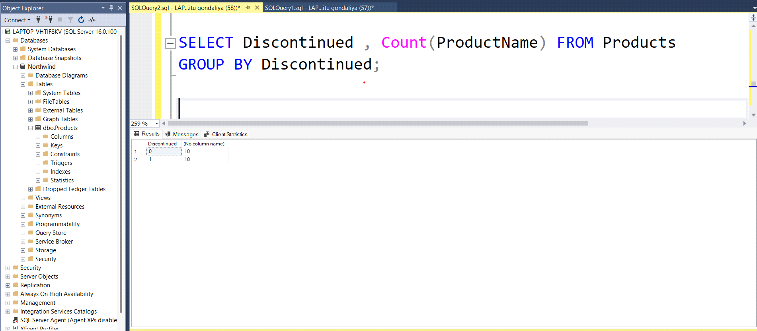

Query 6 :

Write a query to get Product list (name, units on order , units in stock) of stock is lessthan the quantity on order

